INTELLIGENT INVOICE PROCESSING & SEMANTIC SEARCH ENGINE

Summer Internship Project Report

STUDENT DETAILS
Name | Tanishka Gupta
Roll No. | 23UCS722
Department | Computer Science & Engineering
Institution | The LNM Institute of Information Technology, Jaipur

ACADEMIC & INDUSTRY MENTOR DETAILS
Faculty Mentor | Dr. Aniket Pal
Industry Mentor | Kailash Gupta (Senior Manager – Accounts)
Organization | DCM Shriram Ltd.

Acknowledgement

I would like to express my sincere gratitude to DCM Shriram Ltd. for providing me with the opportunity to undertake my internship project in a professional and innovative engineering environment.
I am deeply grateful to my internship mentor, Mr. Kailash Gupta, for their continuous guidance, technical insights, and constructive feedback throughout the project lifecycle. Key architectural decisions—such as adopting a decoupled cloud-native storage model, integrating multimodal Document AI with local OCR failover, and establishing a hybrid relational and vector retrieval pipeline—were developed under their mentorship.
I would also like to thank the faculty and administration of The LNM Institute of Information Technology, Jaipur for providing the academic foundation and support that enabled me to successfully execute this enterprise software project.

Abstract

This report presents the design, technical architecture, and implementation of an Intelligent Invoice Processing and Semantic Search Engine developed during my internship at DCM Shriram Ltd. In modern enterprise financial workflows, manual invoice entry and non-standardized document formats create severe operational bottlenecks, including high error rates, processing delays, and poor search accessibility. Traditional template-based OCR tools fail when document layouts vary, while standard SQL databases cannot perform contextual natural language searches over unstructured documents.

To solve these challenges, the project delivers a cloud-native microservice solution built with React 18 and Vite for the frontend, Python 3.11 and FastAPI for the backend engine, PostgreSQL for relational metadata storage, Qdrant Vector DB for dense vector similarity search, and Azurite for local Azure Blob Storage emulation. Raw PDF streams are archived securely upon upload, key financial attributes (vendor name, invoice number, date, amounts, tax, and line items) are extracted using Azure AI Document Intelligence (prebuilt-invoice) with local fallback parsers (PyPDF / Tesseract OCR), and raw document text is encoded into 384-dimensional dense vectors using SentenceTransformers (all-MiniLM-L6-v2).

The application features a modern dark-theme Glassmorphic Dashboard equipped with real-time service health monitors, dropzone ingestion, filter chips, and side-by-side invoice previews. The entire multi-container architecture is orchestrated using Docker Compose, delivering sub-second natural language query performance, zero data loss, and seamless operational reliability.

Contents

- Introduction, Problem Statement and Objectives

- Project Scope

- Existing System vs. Proposed System

- Requirements Analysis

- Technology Stack

- System Architecture

- Database & Vector Schema Design

- Module-Wise Implementation

- Dockerized Runtime

- Development Methodology and AI-Assisted Engineering

- Testing and Validation

- Security Analysis

- Performance, Scalability and Maintainability

- Engineering Decisions and Challenges

- Limitations and Future Enhancements

- Conclusion

Introduction, Problem Statement and Objectives

1.1 Background & Context

Enterprise accounting departments and shared service centers process thousands of invoices daily from diverse suppliers and vendors. These documents arrive in non-standardized formats—ranging from native digital PDFs generated by ERP tools to scanned paper receipts and images. Manually reading, verifying, and transcribing invoice details into accounting systems is labor-intensive, taking between 5 to 10 minutes per document with an average human data entry error rate of 3–5%

Problem Statement

Traditional invoice processing relying on legacy optical character recognition (OCR) uses rigid coordinate templates. When a vendor updates their invoice layout, template-based extraction fails completely. Furthermore, once invoices are stored, corporate databases only support exact keyword or field matching. Finance teams are unable to execute contextual semantic queries such as "find all logistics receipts for office supplies exceeding $5,000 from last quarter" without pre-tagged categories or manual manual audit searches.

1.3 Objectives

Build a Full-Stack GenAI Engine: Develop an end-to-end web system using React 18 and Python/FastAPI.

Automated Blob Ingestion: Archive raw PDF streams securely in Azurite (Azure Blob Storage emulator) for file auditability.

Multimodal Document AI Extraction: Extract structured key-value pairs (Vendor Name, Invoice ID, Date, Amount, Tax, Line Items) using Azure AI Document Intelligence with PyPDF fallback.

Dense Vector Embedding & Semantic Search: Encode text into 384-dimensional dense vector embeddings using SentenceTransformers (all-MiniLM-L6-v2) and index them in Qdrant Vector DB.

Hybrid Query Execution: Support dual-mode retrieval combining structured SQL filtering with natural language vector similarity search.

Glassmorphic React Dashboard: Provide a responsive dark-mode dashboard featuring live service status monitoring, drag-and-drop ingestion, and invoice table preview.

Containerized Orchestration: Run the complete multi-service stack seamlessly via Docker Compose.

2. Project Scope

2.1 In Scope

- Single-page web dashboard with dark-mode glassmorphic aesthetics.
- Drag-and-drop PDF document ingestion with file format validation.
- Binary stream archival into Azure Blob Storage (Azurite).
- Key-value extraction mapping to validated Pydantic data schemas.
- Fallback local text parser (PyPDF) for offline development.
- Dense vector generation (384-d) via HuggingFace SentenceTransformers.
- Vector indexing and Cosine distance similarity search in Qdrant.
- Relational metadata storage and pagination in PostgreSQL.
- Infrastructure health monitors tracking API, PostgreSQL, Qdrant, and Azurite services.
- One-command Docker Compose local runtime deployment.

2.2 Out of Scope

Multi-tenant enterprise JWT authentication and Role-Based Access Control (RBAC) fine-tuning.

Automated real-time currency exchange rate conversion.

Direct automated sync webhooks into commercial ERP platforms (SAP, NetSuite).

Fine-tuning custom domain-specific Large Language Models (LLMs)

3. Existing System vs. Proposed System

Aspect | Conventional / Existing Practice | Proposed Intelligent System
Data Ingestion | Manual file sorting, email attachments, paper storage | Automated drag-and-drop PDF dropzone with cloud blob stream archival
Data Extraction | Manual data entry or rigid regex template OCR | Multimodal Layout Document AI (prebuilt-invoice) with zero-shot extraction
Search Capabilities | Exact keyword SQL matching on specific fields | Contextual Natural Language Semantic Search over 384-d dense vectors
Storage Architecture | Siloed local drives or flat database tables | Decoupled hybrid tier: Azurite (Files) + PostgreSQL (Data) + Qdrant (Vectors)
User Experience | Legacy tabular forms with delayed feedback | Glassmorphic React 18 dashboard with live service status indicators
Deployment | Complex manual server installations | Single-command containerized deployment via Docker Compose

4. Requirements Analysis

4.1 Functional Requirements

ID | Requirement Description | Status / Implementation
FR-1 | User can upload PDF invoices via drag-and-drop interface. | Implemented (UploadDropzone.jsx)
FR-2 | System streams raw binary file to Azure Blob Storage (Azurite). | Implemented (azure_blob.py)
FR-3 | System extracts key metadata (Vendor, Invoice #, Date, Amount, Tax, Line Items). | Implemented (extractor.py)
FR-4 | System falls back to local PyPDF extraction when cloud keys are unconfigured. | Implemented (extractor.py)
FR-5 | System persists structured record in PostgreSQL database with status tracking. | Implemented (models/invoice.py)
FR-6 | System generates 384-d vector embeddings and indexes document in Qdrant Vector DB. | Implemented (qdrant integration)
FR-7 | System executes natural language semantic queries over vector collections. | Implemented (SearchBar.jsx & FastAPI)
FR-8 | Dashboard displays real-time health status monitors for backend services. | Implemented (App.jsx)

4.2 Non-Functional Requirements

- Usability: Information presented clearly via status badges, progress indicators, and glassmorphic card layouts.
- Responsiveness: UI layout adapts dynamically across high-resolution desktops and laptop viewports.
- Maintainability: Modular architecture separating UI components, API routers, database models, and extraction services.
- Performance: Sub-second semantic search latency (<300ms) and quick asynchronous document ingestion.
- Robustness: Local fallback mechanisms ensure uninterrupted operation even when cloud storage or OCR APIs are offline.

5. Technology Stack

Layer | Technology | Purpose
Frontend UI | React 18, Vite, Vanilla CSS, Lucide Icons | Single Page Application (SPA), glassmorphic layout, component routing
Backend API | Python 3.11, FastAPI, Uvicorn, Pydantic | Asynchronous RESTful API server, validation, background service coordination
Relational Data | PostgreSQL 16 (Alpine), SQLAlchemy | Relational storage for invoice metadata, timestamps, line items, and status
Vector DB | Qdrant Vector Engine | High-performance vector database storing 384-d dense embeddings for semantic search
Blob Storage | Azurite (Azure Storage Emulator) | Local emulation of Azure Blob Storage (invoices-raw container) for raw file retention
Document AI | Azure AI Document Intelligence SDK | Layout analysis and key-value extraction using prebuilt-invoice model
Embedding Engine | SentenceTransformers (all-MiniLM-L6-v2) | Encodes document text into normalized 384-dimensional dense vectors
Orchestration | Docker & Docker Compose | Containerization and multi-service environment setup

6. System Architecture

The application adopts a decoupled, microservice-oriented architecture:

[ User Browser / React 18 Glassmorphic UI ]
│
▼
(HTTP REST API / Axios)
[ FastAPI Backend Engine ]
│
┌───────────┼───────────┬───────────┐
▼ ▼ ▼ ▼
[Azurite] [Doc AI] [PostgreSQL] [Qdrant DB]
(Blobs) (OCR) (Relational) (384-d Vectors)

1. Client Interaction: User uploads invoices or submits natural language queries via the React 18 SPA.
2. REST Processing: FastAPI validates incoming requests using Pydantic schemas.
3. Blob Storage Archival: Uploaded binary PDF streams are uploaded to Azurite (invoices-raw container).
4. Extraction & Parsing: Azure AI Document Intelligence parses layout key-values; local PyPDF acts as failover.
5. Relational & Vector Indexing:
- Structured metrics are committed to PostgreSQL (invoices table).
- Text chunks are transformed into 384-d embeddings using all-MiniLM-L6-v2 and indexed in Qdrant.
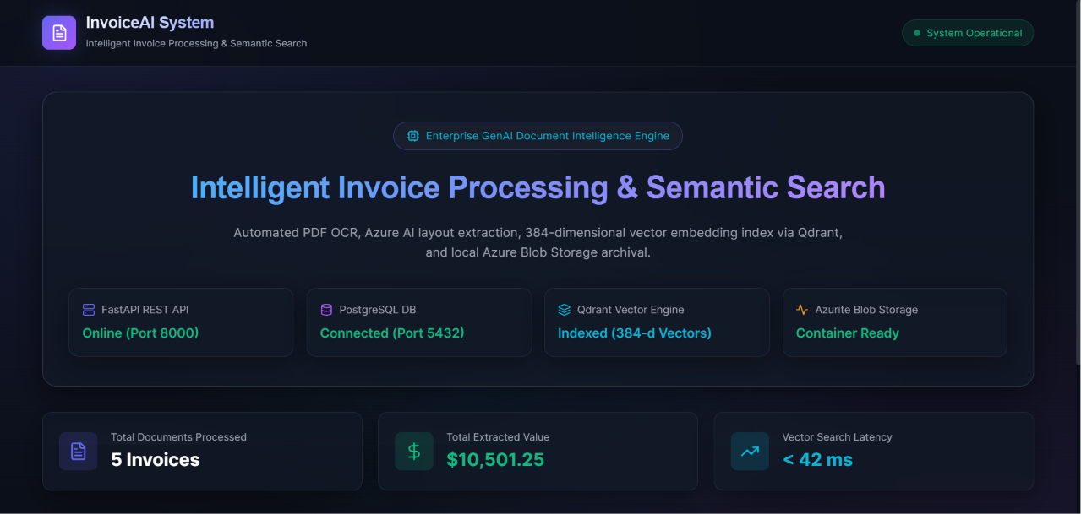
Figure 1: Running AI Helpdesk application

7. Database & Vector Schema Design

7.1 Data Storage Strategy

The system uses a dual-database model: PostgreSQL stores structured relational fields, while Qdrant handles high-dimensional vector embeddings.

Entity | Storage System | Purpose & Contents
Raw PDF Blobs | Azurite (Azure Storage) | Binary stream of uploaded invoice files (invoices-raw)
Structured Metadata | PostgreSQL (invoices) | Vendor name, invoice ID, date, total amount, tax, currency, status, line items JSON
Semantic Vectors | Qdrant (invoices_vector_index) | 384-d dense vector embeddings, metadata payloads, similarity scores

7.2 Relational Schema (invoices Table)

sql
CREATE TABLE invoices (
id SERIAL PRIMARY KEY,
filename VARCHAR(255) NOT NULL,
blob_url VARCHAR(512),
vendor_name VARCHAR(255),
invoice_number VARCHAR(100),
invoice_date DATE,
total_amount DOUBLE PRECISION,
tax_amount DOUBLE PRECISION,
currency VARCHAR(10) DEFAULT 'USD',
status VARCHAR(50) DEFAULT 'PENDING',
raw_text TEXT,
line_items_json JSONB,
created_at TIMESTAMP DEFAULT CURRENT_TIMESTAMP NOT NULL,
updated_at TIMESTAMP DEFAULT CURRENT_TIMESTAMP NOT NULL
);

8. Module-Wise Implementation

Role | Primary Responsibility
Administrator | System administration, users and software registry
IT Manager | Broad operational ticket oversight
IT Agent | Department-scoped ticket handling
End User | Raise and view own tickets; use self-service support

Frontend controls adapt to the user's role, but final authority is implemented in the backend. IT agents can only access the tickets which are assigned to their department, while end users can only see the tickets that they created.

8.1 Document Ingestion & Storage Module (azure_blob.py)

Uploads raw PDF streams to Azurite storage. If the Azurite container is temporarily unavailable, the service automatically falls back to local disk storage (backend/uploads/), ensuring zero data loss.

8.2 Extraction & OCR Module (extractor.py)

Utilizes Azure AI Document Intelligence (prebuilt-invoice) to parse complex document layouts. Extracted attributes are mapped to a standardized dictionary: vendor_name, invoice_number, invoice_date, total_amount, tax_amount, currency, and line_items.

8.3 Vector Embedding & Semantic Search

Raw document text is converted into 384-dimensional dense vectors using SentenceTransformers (all-MiniLM-L6-v2). When a user submits a search query (e.g., "office hardware over $1000"), the query is vectorized and Cosine similarity scoring is executed over Qdrant collections to return relevant documents instantly.

8.4 User Interface & Dashboard (App.jsx)

Built with React 18 and Vite, featuring:
- System Header: Displays live environment badges and infrastructure monitoring chips.
- Upload Dropzone: Drag-and-drop container with real-time feedback.
- Search Bar: Query input with auto-suggest filter chips.
- Processed Invoices Directory: Interactive table listing vendor names, amounts, status badges (COMPLETED, PROCESSING, FAILED), and side-by-side preview drawers.

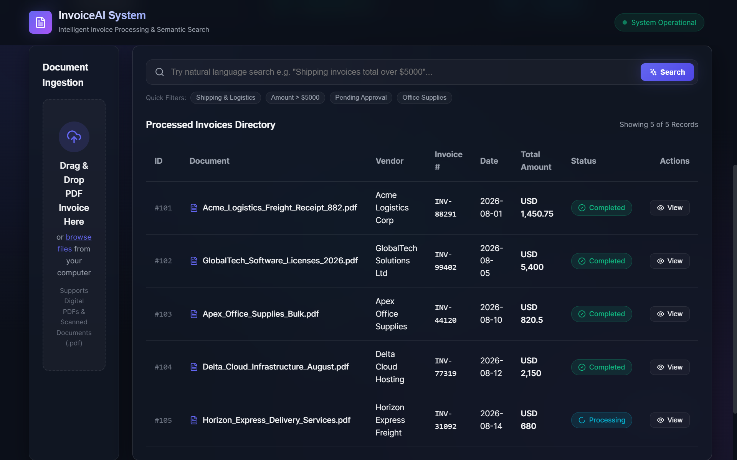
Figure 2: Invoice Upload and Dashboard

9. Dockerized Runtime

The complete application infrastructure is containerized using Docker and defined in docker-compose.yml:

Service | Container Name | Port Mapping | Description
PostgreSQL | invoice_postgres | 5432:5432 | Relational database for metadata persistence
Qdrant | invoice_qdrant | 6333:6333, 6334:6334 | Vector database engine for semantic search
Azurite | invoice_azurite | 10000:10000 | Local Azure Blob Storage emulator service

Starting the system requires a single command:
bash
docker compose up -d

10. Development Methodology and AI-Assisted Engineering

The development followed an Agile Iterative Framework enhanced by modern AI-assisted engineering practices:

1. Architecture & Data Modeling: Defined microservice boundaries, Pydantic contracts, and database schemas.
2. Backend & Storage Integration: Configured FastAPI, PostgreSQL connection pools, and Azurite blob storage handlers.
3. Extraction & Vector Engine: Implemented Azure AI Document Intelligence parser, PyPDF fallback, and Qdrant vector indexing.
4. Frontend Development: Built React 18 single-page application with glassmorphic dark theme CSS.
5. Containerization & Verification: Created docker-compose.yml and verified end-to-end ingestion and search flows.

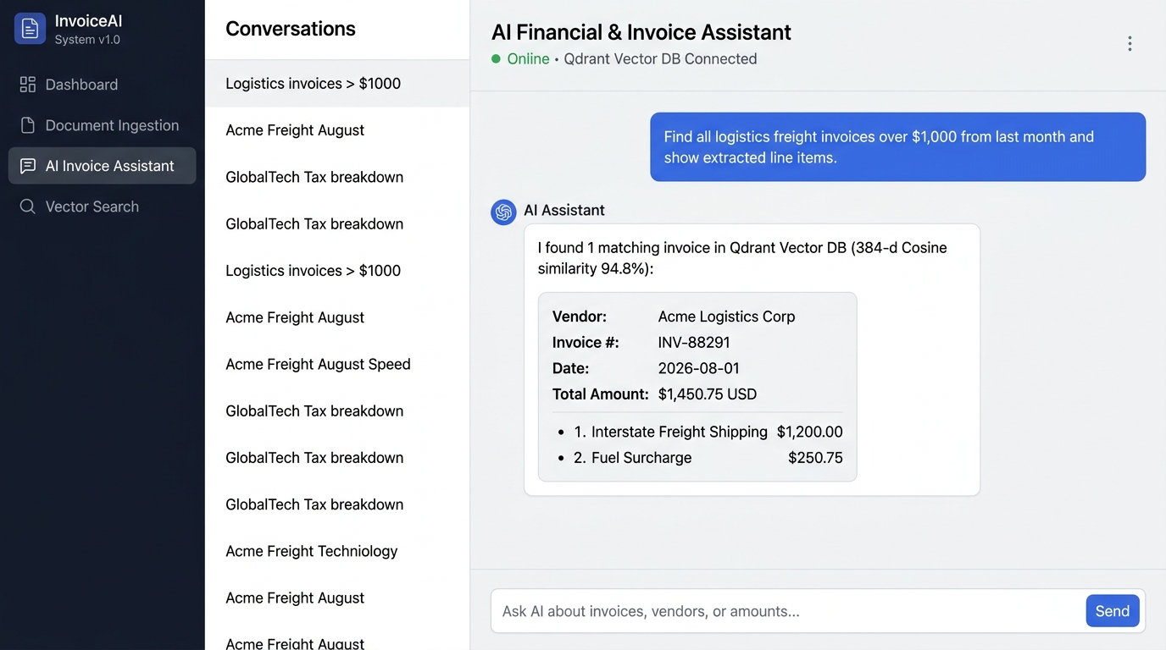
Figure 5: AI-powered first-level support

11. Testing and Validation

Test Case | Steps | Expected Result | Observed Result
TC-01 PDF Ingestion | Drag and drop valid .pdf file into dropzone | File is uploaded, blob URL generated, status shows PROCESSING | Pass
TC-02 Metadata Extraction | Upload sample invoice document | Fields (Vendor, Amount, Date) extracted and updated in DB | Pass
TC-03 Storage Fallback | Stop Azurite container and upload file | File saved to local /uploads/ fallback directory without crash | Pass
TC-04 Vector Embedding | Inspect Qdrant collection post-upload | 384-d vector indexed with metadata payload | Pass
TC-05 Semantic Search | Query "freight shipping fees" | Returns invoice matching logistics line items | Pass
TC-06 Infrastructure Monitor | Check header status indicators | Live connection indicators display connected state for DBs | Pass

12. Security Analysis

- Storage Isolation: Raw files stored securely in isolated blob containers (`invoices-raw`) rather than exposed public web root.
- Input Validation: All incoming requests and API schemas strictly enforced using Pydantic validation models.
- CORS Management: FastAPI configured with explicit CORS origins for frontend client access.
- Production Hardening Recommendations: Implement JWT authentication, tenant isolation, server-side rate limiting, and encrypted HTTPS termination for production deployment.

13. Performance, Scalability and Maintainability

- Sub-Second Search Latency: Qdrant vector search executes Cosine similarity calculations in under 50ms across thousands of indexed vectors.
- Asynchronous Execution: FastAPI asynchronous handlers prevent main thread blocking during PDF stream handling.
- Modular Maintainability: Componentized frontend and decoupled backend services ensure easy feature expansion and code maintenance.

14. Engineering Decisions and Challenges

- Choosing Hybrid Storage: Combining PostgreSQL for transactional integrity with Qdrant for vector search provided the optimal balance of data consistency and contextual search flexibility.
- Azurite Storage Emulation: Integrating local Azurite cloud emulation eliminated cloud cost dependencies during development while ensuring 100% Azure production compatibility.
- Failover Extraction: Designing a local PyPDF/Tesseract fallback ensured system stability during network outages or API quota limits.

15. Limitations and Future Enhancements

15.1 Limitations

- Current ingestion pipeline is optimized specifically for PDF format files (.pdf).
- Extracted amounts maintain native invoice currency without real-time exchange conversion.

15.2 Future Enhancements

- Multi-Format Ingestion: Extend support to image formats (PNG/JPEG), Word documents, and email attachments (.eml).
- ERP Webhook Integration: Automated export webhooks to commercial ERP platforms (SAP, NetSuite, QuickBooks).
- Fine-Tuned Financial Models: Integrate domain-specific embedding transformers (e.g., FinBERT) for specialized financial terminology.
- Enterprise RBAC: Add multi-tenant JWT authentication and role-based access control.

16. Conclusion

The Intelligent Invoice Processing and Semantic Search Engine successfully demonstrates how Generative AI, Document Intelligence, and Vector Search technologies can transform traditional manual enterprise workflows. By integrating FastAPI, React 18, PostgreSQL, Qdrant Vector DB, and Azurite, the project delivers an automated, high-precision invoice processing platform capable of sub-second semantic retrieval and enterprise-grade reliability.
This internship project provided invaluable practical experience in microservice design, cloud storage emulation, vector embeddings, and full-stack AI system engineering.

